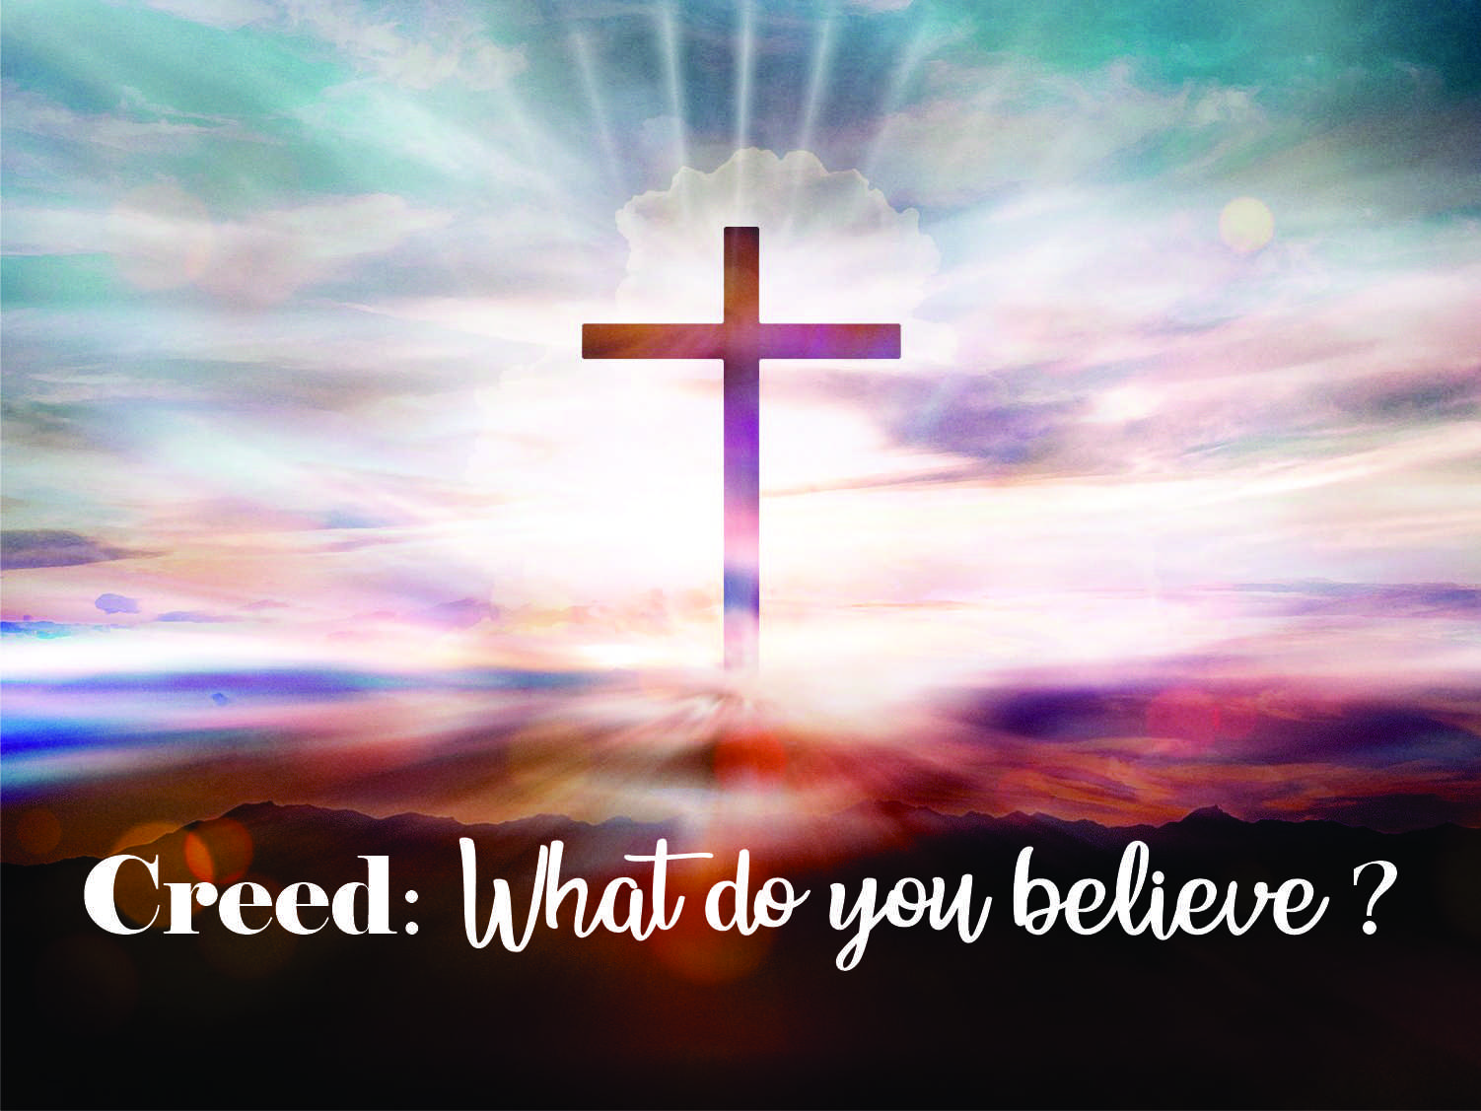
LIVING WITH GOD’S PEOPLE

10/18/20 – Psalm 122:1-5, etc.

LIVING WITH GOD’S PEOPLE MEANS:

- IF YOU BELIEVE IN SOMETHING, YOU _______________ IT.
  - I believe … in the holy catholic church, the communion of saints…
    - The holy catholic church = the ____________________ church (Eph.
2:19).
    - The communion of saints = the ____________________ church (Hebrews
10:25).

- IF YOU BELIEVE IN SOMETHING, YOU _______________ IT.
  - See Psalm 122:1.
  - How do you invite them?
    - With _________________________.
    - To come ____________________ you.
    - To see what ____________________.

- IF YOU BELIEVE IN SOMETHING, YOU _______________ IT.
  - ‘Communion’ implies you are in it all the way (1 Cor. 12:25)!
  - Ways to support Trinity UMC:
    - _________________________.
    - _________________________.
    - _________________________.
    - _________________________.
    - _________________________.

CONCLUSION: How much do you believe in the universal church? How much do you believe in Trinity UMC?

